**Title: Aircrack-ng Wireless Network Security Assessment**

**Name: Harshitaa Ashish**

**Summary:**

The Aircrack-ng Wireless Network Security Assessment report delves into the vital role of Aircrack-ng in evaluating and enhancing the security of wireless networks. Acknowledging the pervasive vulnerabilities inherent in wireless systems, the report emphasizes the necessity of robust security measures to combat threats like unauthorized access and data interception. Through practical demonstrations and analysis, the report aims to showcase Aircrack-ng's efficacy in identifying vulnerabilities, such as weak encryption protocols and rogue access points, thereby fortifying network defences. It outlines the objectives of the assessment, including evaluating network security, identifying weaknesses, providing recommendations, and raising awareness. Additionally, the report delineates its scope, ensuring adherence to legal and ethical guidelines, and outlines its structure for clarity and guidance. By illuminating the capabilities of Aircrack-ng and its pivotal role in wireless network security, the report equips readers with the insights and tools necessary to fortify their network infrastructure effectively.

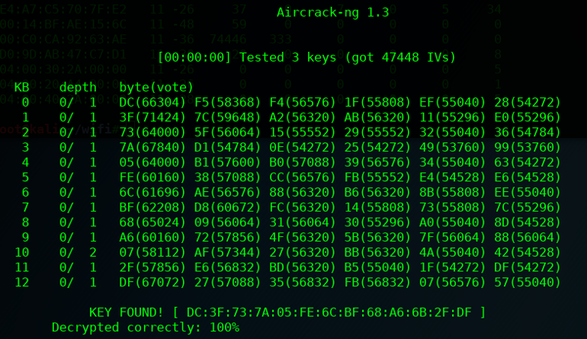

Top of Form

**Introduction:**

In an increasingly interconnected world, the security of wireless networks plays a pivotal role in safeguarding sensitive data and ensuring the integrity of digital communications. Wireless networks, while offering convenience and flexibility, are inherently susceptible to a wide range of security threats, including unauthorized access, data interception, and network intrusion. As such, conducting comprehensive security assessments of wireless networks is essential for identifying vulnerabilities and implementing robust security measures.

The Aircrack-ng suite emerges as a powerful toolset for conducting wireless network security assessments, providing a comprehensive set of tools for capturing, analysing, and assessing the security of wireless networks. Aircrack-ng is renowned for its versatility and effectiveness in identifying security vulnerabilities, ranging from weak encryption protocols to rogue access points.

**Objective:**

* Evaluate Network Security: Assess the security posture of wireless networks by identifying vulnerabilities and potential attack vectors.
* Identify Security Weaknesses: Identify common security weaknesses, such as weak encryption, default configurations, and unauthorized access points.

**Features**

Network Scanning:

Conducts thorough scans of wireless networks to identify access points and connected devices, providing insights into network topology and potential security risks.

Packet Capture and Analysis:

Captures network traffic for detailed analysis, allowing users to identify anomalies, unauthorized devices, and potential security threats within the network.

Vulnerability Assessment:

Assesses the security vulnerabilities of wireless networks, including weak encryption protocols, default configurations, and open ports, to prioritize remediation efforts.

Encryption Key Cracking:

Provides capabilities to crack WEP, WPA, and WPA2 encryption keys, enabling the identification of networks vulnerable to unauthorized access and data interception.

Access Point Detection:

Detects rogue access points within the network, which may pose security risks by providing unauthorized access to network resources, enhancing overall network visibility.

Reporting:

Generates customizable reports summarizing assessment findings, including identified vulnerabilities, recommendations, and remediation steps, facilitating informed decision-making and communication with stakeholders.

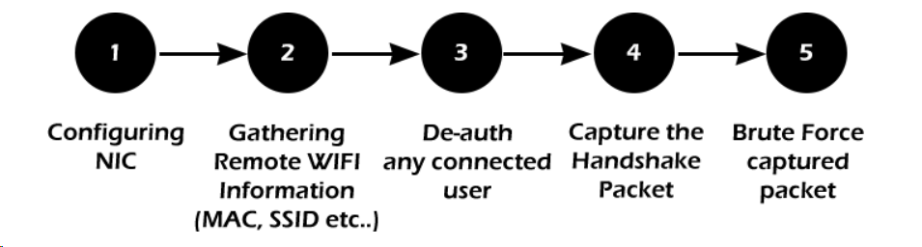

**Use in digital forensics and cybersecurity**

Wireless Network Forensics:

* Aircrack-ng's packet capture capabilities aid in reconstructing network communications, crucial in investigating cybercrimes involving wireless networks.
* It helps forensic analysts identify unauthorized access, data breaches, and malicious activities by scrutinizing captured network traffic.

Incident Response:

* During cybersecurity incidents involving wireless networks, Aircrack-ng assists in swift incident containment and mitigation by pinpointing compromised access points, rogue devices, and malicious network activities.
* It empowers incident responders to quickly assess the extent of a breach and formulate effective countermeasures.

Malware Analysis:

* In cases where malware employs wireless channels for communication or data exfiltration, Aircrack-ng aids in analysing network traffic to detect malware presence and behaviour.
* Analysts leverage Aircrack-ng to decipher malicious communication patterns and discern infiltration tactics employed by malware, facilitating the development of mitigation strategies.

Security Audits and Compliance:

* Aircrack-ng's vulnerability assessment capabilities prove instrumental in security audits and compliance checks concerning wireless network security standards.
* Auditors rely on Aircrack-ng to identify security loopholes, such as weak encryption, unauthorized access points, and misconfigurations, ensuring organizations adhere to regulatory requirements.

Research and Development:

* Aircrack-ng provides a robust platform for cybersecurity researchers and developers to experiment, innovate, and validate new wireless network security techniques and technologies.
* Researchers leverage Aircrack-ng to explore novel approaches to wireless security, contributing to the advancement of cybersecurity knowledge and solutions.

**Methodology**

1. Preparation:

Define the objectives and scope of the security assessment, including the target network(s) to be assessed. Obtain necessary authorization and permissions to conduct the assessment, ensuring compliance with legal and ethical guidelines. Set up the testing environment, including installing Aircrack-ng on the appropriate platform and ensuring compatibility with the wireless adapter.

1. Network Reconnaissance:

Use Aircrack-ng to perform initial reconnaissance by scanning for available wireless networks in the vicinity. Gather information about identified networks, including SSIDs, signal strength, encryption types, and connected devices.

1. Packet Capture:

Select target wireless networks for detailed analysis and initiate packet capture using Aircrack-ng tools, such as Airodump-ng. Capture network traffic to collect data packets transmitted over the wireless network, including management, control, and data frames.

1. Traffic Analysis:

Analyse captured packets using Aircrack-ng tools and utilities, such as Wireshark or Aireplay-ng, to identify patterns, anomalies, and security-related information. Examine packet headers, payloads, and protocol behaviours to understand network communication patterns and detect potential security threats.

1. Vulnerability Assessment:

Utilize Aircrack-ng tools, such as Aircrack-ng suite and Airmon-ng, to assess the security vulnerabilities of the target wireless network(s). Identify common security weaknesses, such as weak encryption, default configurations, and rogue access points, using techniques like packet injection and authentication attacks.

1. Encryption Key Cracking:

Attempt to crack the encryption keys of secured wireless networks using Aircrack-ng's capabilities for WEP, WPA, and WPA2 encryption. Employ dictionary-based or brute-force attacks to exploit vulnerabilities in encryption protocols and gain unauthorized access to the network.

1. Rogue Access Point Detection:

Detect rogue access points within the target network(s) using Aircrack-ng tools, such as Airodump-ng and Airmon-ng. Identify unauthorized access points that may pose security risks by providing unauthorized access to network resources.

1. Reporting and Documentation:

Compile findings, analysis, and recommendations into a comprehensive report documenting the results of the security assessment. Include details on identified vulnerabilities, exploitation techniques, risk assessments, and recommendations for mitigating security risks. Present the report in a clear and actionable format, tailored to the needs of stakeholders, such as network administrators, security professionals, and management.

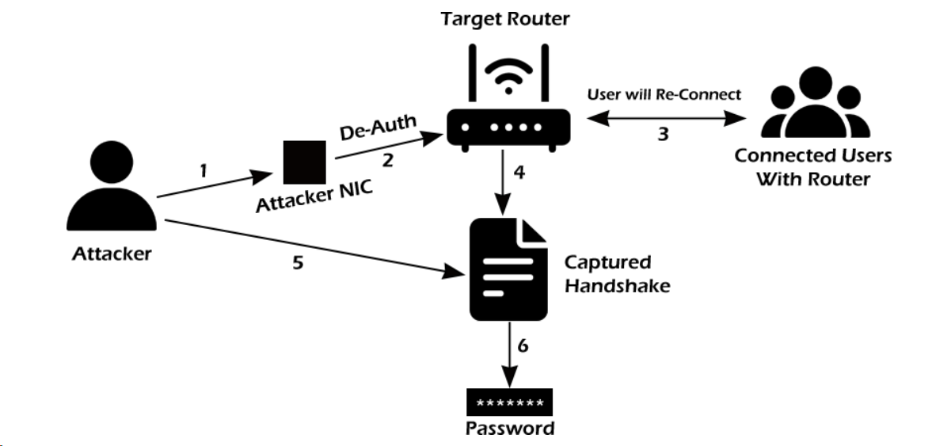

**Demonstration**

1. Airmon-ng: Monitor Mode

Airmon-ng is used to manage wireless extensions modes. To sniff a wireless connection, you must switch your wireless card from managed to monitor mode, which is done with airmon-ng. Monitor mode allows your card to listen in on all packets in the air. Normally, only packets intended for you will be "heard" by your card. We can later capture the WPA/WPA2 4-way handshake by listening to every packet.

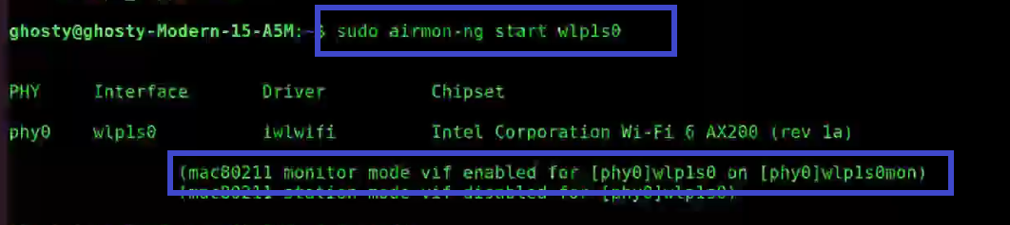

1. Airodump-ng: Authentication Handshake

Airodump-ng is a wireless sniffer that can collect data from several wireless Access Points. It's used to look for nearby Access Points and record handshakes.

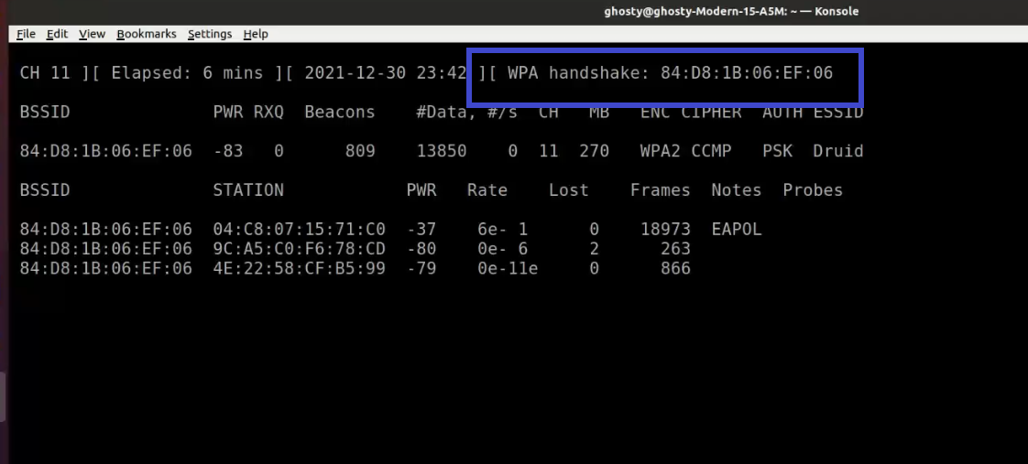

1. Aireplay-ng: Deauthenticate Client

Aireplay-ng is a replay attack and packet injector tool. Users can be de-authenticated from their APs to collect handshakes. This step is only required if you have decided to speed up the process. Another constraint is that the AP must be connected to a wireless client at this time. If no wireless client is currently connected to the AP, you must be patient and wait for one to connect before capturing a handshake. You can go back and repeat this step if a wireless client arises later and Airodump-ng fails to capture the handshake.

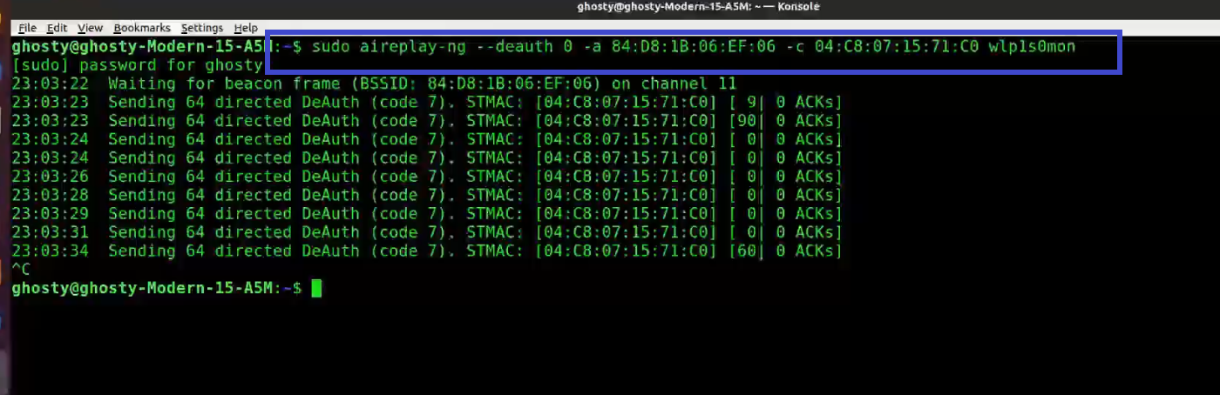

1. Aircrack-ng

To find the key, Aircrack-ng is used to attack WPA/WAP2 wireless protocols. For cracking the password Aircrack-ng uses brute force attack against the captured handshake. The drawback of using Aircrack-ng to brute force is that it utilizes CPU instead of GPU which makes the attack slow.

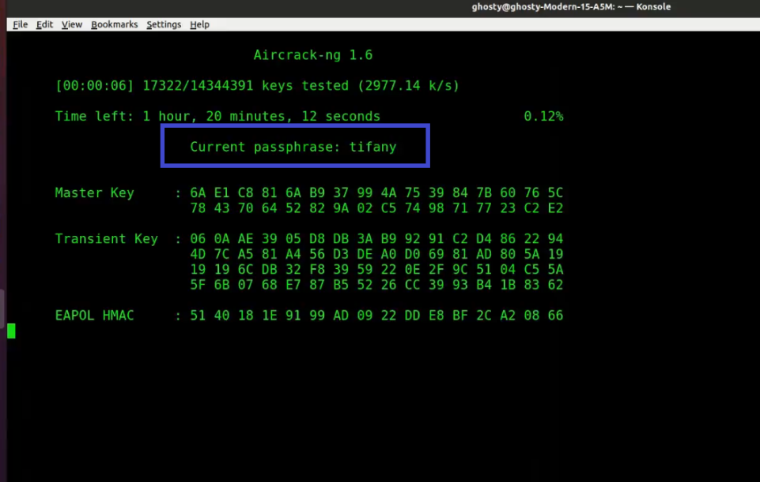

**Conclusion**

In conclusion, the Aircrack-ng Wireless Network Security Assessment has revealed critical insights into the vulnerabilities inherent in wireless networks and the effectiveness of Aircrack-ng as a tool for assessing and fortifying network security. Through meticulous scanning, packet analysis, and vulnerability assessment, we have unearthed prevalent weaknesses like weak encryption, default configurations, and rogue access points. These findings underscore the urgency for organizations to bolster their network defences and proactively mitigate security risks. By leveraging Aircrack-ng's capabilities and implementing recommended security measures, organizations can significantly enhance the resilience of their wireless networks against cyber threats, safeguarding sensitive data and preserving the integrity of network communications.

**Resources/references:**

[**https://www.aircrack-ng.org/doku.php?id=aircrack-ng**](https://www.aircrack-ng.org/doku.php?id=aircrack-ng)

[**https://techofide.com/blogs/how-to-use-aircrack-ng-aircrack-ng-tutorial-practical-demonstration/**](https://techofide.com/blogs/how-to-use-aircrack-ng-aircrack-ng-tutorial-practical-demonstration/)

[**https://www.secureideas.com/blog/2018/09/introduction-to-wireless-security-with-aircrack-ng.html**](https://www.secureideas.com/blog/2018/09/introduction-to-wireless-security-with-aircrack-ng.html)